TRAINING PROJECT ON BANKING IN C++ LANGUAGE

A TRANING PROJECT

Submitted to

ER. PADAM JEET SINGH

Submitted by

SIMARJIT SINGH
REG.NO. 00813622891

In training for the award of the diploma

Of

COMPUTER ENGINEERING

IN

5TH SEMESTER

At

GOVT. POLYTECHNIC COLLEGE

BHIKHIWIND

TABLE OF CONTENTS

Sr. no. | NAME | PAGE NO.
 | Acknowledgement | 1
 | Abstract of project | 2
 | Introduction of c++ | 3-11
 | About of project | 12
 | Working description of project | 13
 | Header files and their purpose | 14
 | Files generated | 15
 | Outputs | 16-27
 | Conclusion | 28
 | Scope of future | 29
12. | Bibliography | 30

ACKNOWLEDGEMENT

I have the honors to express my deep sense of gratitude to our project guide Er. Padamjit singh, Lecturer Govt. Polytechnic College, Bhikhiwind. I made this project in major project subject on c++ language. It would be my utmost pleasure to express my sincere thanks to My major project Teacher Mr. padamjit singh in providing a helping hand in this project. His patience, creativity and immense knowledge that he shared with me have proved highly beneficial to me and have made my Project File both possible and successful.

SUBMITTED BY:
Name : SIMARJIT SINGH
REG.NO. 008136228391

ABSTRACT

This project is use to keep the record of accounts in the bank. The main purpose of this project is

New account – The new account is used to open the new account
in banking project.

List of all account- It is used to easy view of all account
available in bank

All transaction of account – It is used to see the all Transaction information of the account.

Daily transaction –In the daily transaction we can deposit or
Withdraw in the account. let we deposit the rupees in account then put the cash or draft and after enter the amount.

Monthly report- This option is used for take monthly information account report .

Edit account - The edit option is used to the modify the account and close the account.

Exit – The exit option is used to the Exit of banking project.

INTRODUCTION OF C++ :

During the 1980s and into the 1990s, an explosive growth in object-oriented technology began with the introduction of the Smalltalk language. Object-Oriented Programming (OOP) began to replace the more traditional structured programming techniques. This explosion led to the development of languages which support programming with objects. Many new object-oriented programming languages appeared: Object-Pascal, Modula-2, Mesa, Cedar, Neon, Objective-C, LISP with the Common List Object System (CLOS), and, of course, C++. Although many of these languages appeared in the 1980s, many ideas of OOP were taken from Simula-67. Yes! OOP has been around since 1967.
C++ originated with Bjarne Stroustrop. In the simplest sense, if not the most accurate, we can consider it to be a better C. Although it is not an entirely new language, C++ represents a significant extension of C abilities. We might then consider C to be a subset of C++. C++ supports essentially every desirable behavior and most of the undesirable ones of its predecessor, but provides general language improvements as well as adding OOP capability. This tutorial is a collection of lectures to be held in the on-line course Introduction to Object-Oriented Programming Using C++ . In this course, object-orientation is introduced as a new programming concept which should help you in developing high quality software. Object-orientation is also introduced as a concept which makes developing of projects easier. However, this is not a course for learning the C++ programming language. If you are interested in learning the language itself, you might want to go through other tutorials, such as C++: Annotations by Frank Broken and Karel Kubat. In this tutorial only those language concepts that are needed to present coding examples are introduced. And what makes object-orientation such a hot topic? To be honest, not everything that is sold under the term of object-orientation is really new. For example, there are programs written in procedural languages like Pascal or C which use object-oriented concepts. But there exist a few important features which these languages won't handle or won't handle very well, respectively. Some people will say that object-orientation is ``modern''. When reading announcements of new products everything seems to be ``object-oriented''. ``Objects'' are everywhere. In this tutorial we will try to outline characteristics of object-orientation to allow you to judge those object-oriented products.
The designers of C++ wanted to add object-oriented mechanisms without compromising the efficiency and simplicity that made C so popular. One of the driving principles for the language designers was to hide complexity from the programmer, allowing her to concentrate on the problem at hand. Because C++ retains C as a subset, it gains many of the attractive features of the C language, such as efficiency, closeness to the machine, and a variety of built-in types. A number of new features were added to C++ to make the language even more robust, many of which are not used by novice programmers. By introducing these new features here, we hope that you will begin to use them in your own programs early on and gain their benefits. Some of the features we will look at are the role of constants, inline expansion, references, declaration statements, user defined types, overloading, and the free store. Most of these features can be summarized by two important design goals: strong compiler type checking and a user-extensible language. By enforcing stricter type-checking, the C++ compiler makes us acutely aware of data types in our expressions. Stronger type checking is provided through several mechanisms, including: function argument type checking, conversions, and a few other features we will examine below.
C++ also enables programmers to incorporate new types into the language, through the use of classes. A class is a user-defined type. The compiler can treat new types as if they are one of the built-in types. This is a very powerful feature. In addition, the class provides the mechanism for data abstraction and encapsulation, which are key to object-oriented programming. As we examine some of the new features of C++ we will see these two goals resurface again and again.
BASIC CONCEPT OF OBJECT ORIENTED PROGRAMMING
Class
A class is an actual representation of an ADT. It therefore provides implementation details for the data structure used and operations. We play with the ADT Integer and design our own class for it:
class Integer {
attributes:
int i

methods:
setValue(int n)
Integer addValue(Integer j)
}
In the example above as well as in examples which follow we use a notation which is not programming language specific. In this notation class {...} denotes the definition of a class. Enclosed in the curly brackets are two sections attributes: and methods: which define the implementation of the data structure and operations of the corresponding ADT. Again we distinguish the two levels with different terms: At the implementation level we speak of ``attributes'' which are elements of the data structure at the ADT level. The same applies to ``methods'' which are the implementation of the ADT operations.
Abstract Classes
With inheritance we are able to force a subclass to offer the same properties like their superclasses. Consequently, objects of a subclass behave like objects of their superclasses.
Sometimes it make sense to only describe the properties of a set of objects without knowing the actual behaviour beforehand. In our drawing program example, each object should provide a method to draw itself on the drawing area. However, the necessary steps to draw an objects depends on its represented shape. For example, the drawing routine of a circle is different from the drawing routine of a rectangle.

Objects
C++ introduces object-oriented (OO) features to C. It offers classes, which provide the four features commonly present in OO (and some non-OO) languages: abstraction, encapsulation, inheritance, and polymorphism. Objects are instances of classes created at runtime. The class can be thought of as a template from which many different individual objects may be generated as a program runs.
Encapsulation
Encapsulation is the hiding of information in order to ensure that data structures and operators are used as intended and to make the usage model more obvious to the developer. C++ provides the ability to define classes and functions as its primary encapsulation mechanisms. Within a class, members can be declared as either public, protected, or private in order to explicitly enforce encapsulation. A public member of the class is accessible to any function. A private member is accessible only to functions that are members of that class and to functions and classes explicitly granted access permission by the class ("friends"). A protected member is accessible to members of classes that inherit from the class in addition to the class itself and any friends.
The OO principle is that all of the functions (and only the functions) that access the internal representation of a type should be encapsulated within the type definition. C++ supports this (via member functions and friend functions), but does not enforce it: the programmer can declare parts or all of the representation of a type to be public, and is allowed to make public entities that are not part of the representation of the type. Because of this, C++ supports not just OO programming, but other weaker decomposition paradigms, like modular programming.
It is generally considered good practice to make all data private or protected, and to make public only those functions that are part of a minimal interface for users of the class. This hides all the details of data implementation, allowing the designer to later fundamentally change the implementation without changing the interface in any way.
Inheritance
Inheritance allows one data type to acquire properties of other data types. Inheritance from a base class may be declared as public, protected, or private. This access specifier determines whether unrelated and derived classes can access the inherited public and protected members of the base class. Only public inheritance corresponds to what is usually meant by "inheritance". The other two forms are much less frequently used. If the access specifier is omitted, a "class" inherits privately, while a "struct" inherits publicly. Base classes may be declared as virtual; this is called virtual inheritance. Virtual inheritance ensures that only one instance of a base class exists in the inheritance graph, avoiding some of the ambiguity problems of multiple inheritance.
Multiple inheritance is a C++ feature sometimes considered controversial. Multiple inheritance allows a class to be derived from more than one base class; this can result in a complicated graph of inheritance relationships. For example, a "Flying Cat" class can inherit from both "Cat" and "Flying Mammal". Some other languages, such as Java or C#, accomplish something similar (although more limited) by allowing inheritance of multiple interfaces while restricting the number of base classes to one (interfaces, unlike classes, provide only declarations of member functions, no implementation or member data). Interfaces and abstract classes in Java and C# can be approximated in C++ as a class containing only function declarations, often known as an abstract base class or "ABC." Programmers preferring the Java/C# model of inheritance can choose to inherit only one non-abstract class, although in this case the declared member functions of the abstract base classes must be explicitly defined and cannot be inherited. Polymorphism
Polymorphism enables one common interface for many implementations, and for objects to act differently under different circumstances.
C++ supports several kinds of static (compile-time) and dynamic (run-time) polymorphisms. Compile-time polymorphism does not allow for certain run-time decisions, while run-time polymorphism typically incurs a performance penalty.
Static polymorphism
Function overloading allows programs to declare multiple functions having the same name (but with different arguments). The functions are distinguished by the number and/or types of their formal parameters. Thus, the same function name can refer to different functions depending on the context in which it is used. The type returned by the function is not used to distinguish overloaded functions.
When declaring a function, a programmer can specify default arguments for one or more parameters. Doing so allows the parameters with defaults to optionally be omitted when the function is called, in which case the default arguments will be used. When a function is called with fewer arguments than there are declared parameters, explicit arguments are matched to parameters in left-to-right order, with any unmatched parameters at the end of the parameter list being assigned their default arguments. In many cases, specifying default arguments in a single function declaration is preferable to providing overloaded function definitions with different numbers of parameters.
Templates in C++ provide a sophisticated mechanism for writing generic, polymorphic code. In particular, through the Curiously Recurring Template Pattern it's possible to implement a form of static polymorphism that closely mimics the syntax for overriding virtual functions. Since C++ templates are type-aware and Turing-complete they can also be used to let the compiler resolve recursive conditionals and generate substantial programs through template metaprogramming.
Dynamic polymorphism
C++ also provides a dynamic_cast operator, which allows the program to safely attempt conversion of an object into an object of a more specific object type (as opposed to conversion to a more general type, which is always allowed). This feature relies on run-time type information (RTTI). Objects known to be of a certain specific type can also be cast to that type with static_cast, a purely compile-time construct which is faster and does not require RTTI.
Virtual member functions
Ordinarily when a function in a derived class overrides a function in a base class, the function to call is determined by the type of the object. A given function is overridden when there exists no difference, in the number or type of parameters, between two or more definitions of that function. Hence, at compile time it may not be possible to determine the type of the object and therefore the correct function to call, given only a base class pointer; the decision is therefore put off until runtime. This is called dynamic dispatch. Virtual member functions or methods allow the most specific implementation of the function to be called, according to the actual run-time type of the object. In C++, this is commonly done using virtual function tables. If the object type is known, this may be bypassed by prepending a fully qualified class name before the function call, but in general calls to virtual functions are resolved at run time.
In addition to standard member functions, operator overloads and destructors can be virtual. A general rule of thumb is that if any functions in the class are virtual, the destructor should be as well. As the type of an object at its creation is known at compile time, constructors, and by extension copy constructors, cannot be virtual. Nonetheless a situation may arise where a copy of an object needs to be created when a pointer to a derived object is passed as a pointer to a base object. In such a case a common solution is to create a clone() (or similar) function and declare that as virtual. The clone() method creates and returns a copy of the derived class when called.
A member function can also be made "pure virtual" by appending it with = 0 after the closing parenthesis and before the semicolon. Objects cannot be created of a class with a pure virtual function and are called abstract data types. Such abstract data types can only be derived from. Any derived class inherits the virtual function as pure and must provide a non-pure definition of it (and all other pure virtual functions) before objects of the derived class can be created. A program that attempts to create an object of a class with a pure virtual member function or inherited pure virtual member function is ill-formed.
MESSAGE---[Definition (Message) A message is a request to an object to invoke one of its methods. A message therefore contains
the name of the method and
the arguments of the method.
Consequently, invocation of a method is just a reaction caused by receipt of a message. This is only possible, if the method is actually known to the object.
Definition (Method) A method is associated with a class. An object invokes a method as a reaction to receipt of a message.
Operators and operator overloading
C++ provides more than 30 operators, covering basic arithmetic, bit manipulation, indirection, comparisons, logical operations and others. Almost all operators can be overloaded for user-defined types, with a few notable exceptions such as member access (. and .*). The rich set of overloadable operators is central to using C++ as a domain specific language. The overloadable operators are also an essential part of many advanced C++ programming techniques, such as smart pointers. Overloading an operator does not change the precedence of calculations involving the operator, nor does it change the number of operands that the operator uses (any operand may however be ignored).
Array --- An array is a series of elements of the same type placed in contiguous memory locations that can be individually referenced by adding an index to a unique identifier.
That means that, for example, we can store 5 values of type int in an array without having to declare 5 different variables, each one with a different identifier. Instead of that, using an array we can store 5 different values of the same type, int for example, with a unique identifier.

Pointers:
Every storage location of memory has an associated address. Address is a number that grows sequentially. For every program placed in memory, each variable or function in the program has an associated address.
Structures and unions
A structure contains an ordered group of data objects. Unlike the elements of an array, the data objects within a structure can have varied data types. Each data object in a structure is a member or field.
A union is an object similar to a structure except that all of its members start at the same location in memory. A union variable can represent the value of only one of its members at a time.
Function declarations and definitions
The distinction between a function declaration and function definition is similar to that of a data declaration and definition. The declaration establishes the names and characteristics of a function but does not allocate storage for it, while the definition allocates specifies the body for a function, associates an identifier with the function, and allocates storage for it. Thus, the identifiers declared in this example:
float square(float x);
do not allocate storage.
The function definition contains a function declaration and the body of a function. The body is a block of statements that perform the work of the function. The identifiers declared in this example allocate storage; they are both declarations and definitions.
float square(float x)
{ return x*x; }
A function can be declared several times in a program, but all declarations for a given function must be compatible; that is, the return type is the same and the parameters have the same type. However, a function can only have one definition. Declarations are typically placed in header files, while definitions appear in source files.
Templates
C++ templates enable generic programming. C++ supports both function and class templates. Templates may be parameterized by types, compile-time constants, and other templates. C++ templates are implemented by instantiation at compile-time. To instantiate a template, compilers substitute specific arguments for a template's parameters to generate a concrete function or class instance. Templates are a powerful tool that can be used for generic programming, template metaprogramming, and code optimization, but this power implies a cost. Template use may increase code size, since each template instantiation produces a copy of the template code: one for each set of template arguments. This is in contrast to run-time generics seen in other languages (e.g. Java) where at compile-time the type is erased and a single template body is preserved.
Templates are different from macros: while both of these compile-time language features enable conditional compilation, templates are not restricted to lexical substitution. Templates are aware of the semantics and type system of their companion language, as well as all compile-time type definitions, and can perform high-level operations including programmatic flow control based on evaluation of strictly type-checked parameters. Macros are capable of conditional control over compilation based on predetermined criteria, but cannot instantiate new types, recurse, or perform type evaluation and in effect are limited to pre-compilation text-substitution and text-inclusion/exclusion. In other words, macros can control compilation flow based on pre-defined symbols but cannot, unlike templates, independently instantiate new symbols. Templates are a tool for static polymorphism (see below) and generic programming.
In addition, templates are a compile time mechanism in C++ which is Turing-complete, meaning that any computation expressible by a computer program can be computed, in some form, by a template metaprogram prior to runtime.
In summary, a template is a compile-time parameterized function or class written without knowledge of the specific arguments used to instantiate it. After instantiation the resulting code is equivalent to code written specifically for the passed arguments. In this manner, templates provide a way to decouple generic, broadly-applicable aspects of functions and classes (encoded in templates) from specific aspects (encoded in template parameters) without sacrificing performance due to abstraction.
Control flow
In computer science control flow (or alternatively, flow of control) refers to the order in which the individual statements, instructions, or function calls of an imperative or functional program are executed or evaluated.
Within an imperative programming language, a control flow statement is a statement whose execution results in a choice being made as to which of two or more paths should be followed. For non-strict functional languages, functions and language constructs exist to achieve the same result, but they are not necessarily called control flow statements.
The kinds of control flow statements supported by different languages vary, but can be categorized by their effect:
continuation at a different statement (unconditional branch or jump),
executing a set of statements only if some condition is met (choice - i.e. conditional branch),
executing a set of statements zero or more times, until some condition is met (i.e. loop - the same as conditional branch),
executing a set of distant statements, after which the flow of control usually returns (subroutines, coroutines, and continuations),
stopping the program, preventing any further execution (unconditional halt).

ABOUT OF PROJECT

This project is use to keep the record of accounts in the bank. The main purpose of this project is easy to open the new account in bank. It is used to easy view of all account available in bank. In the daily transaction we can deposit or Withdraw in the account. let we deposit the rupees in account then put the cash or draft and after enter the amount. The monthly report is provide the all information of the last month accounts. The edit option is used to the modify the account and close the account. This project is easy to find the available account in the bank. But only those accounts can be find which are add in the record. In this record we can view name of person ,home address and amount. This project is mostly used for daily transaction in the account. Though this project we can view monthly report of account. In this project we can see easily exact time, day and month of deposit or withdraw the amount.

WORKING DESCRIPTION OF
PROJECT

This program consists of SEVEN options as follows

NEW ACCOUNT
LIST OF ACCOUNT
SEE TRANSACTION OF ACCOUNT
DAILY TRANSACTION
MONTHLY PERORT
EDIT ACCOUNT
EXIT

HEADER FILES USED AND THEIR PURPOSE

- FSTREAM.H – for file handling, cin and cout
- PROCESS.H – for exit() function
- CONIO.H – for clrscr() and getch() functions
- STDIO.H – for standard I/O operations
- DOS.H – for execution of program
- STRING.H – for string handling
- GRAPHICS.H – for graphical display
- IOMANIP.H–for C++ streams I/O manipulators

FILES GENERATED

DATA FILES
BANK.DAT

PROGRAM FILE
BANK.CPP

OBJECT FILE
BANK.OBJ

EXECUTION FILE
BANK.EXE

PROGRAM OUTPUT:-

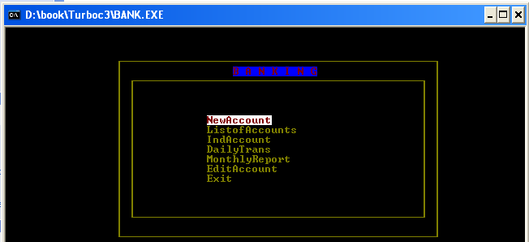

When enter our choice : NEW ACCOUNT

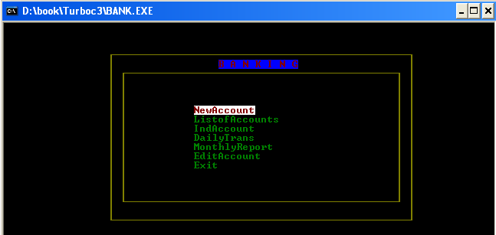

Output obtained by choosing the first option is to open the new account in bank.

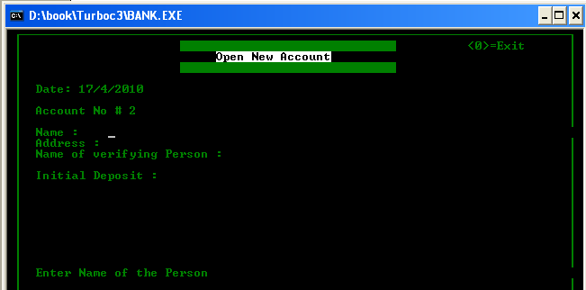

When enter our choice : LIST OF ALL ACCOUNTS

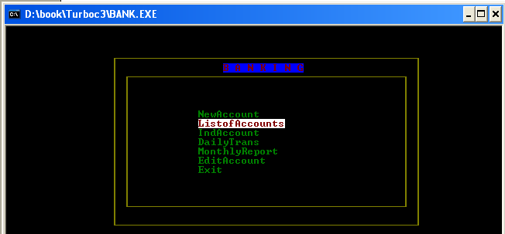

Output obtained by choosing the second option see all accounts list.

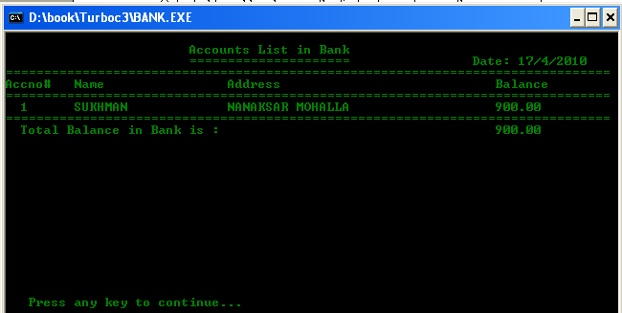
When enter our choice : SEE ALL TRANSACTION OF ACCOUNT

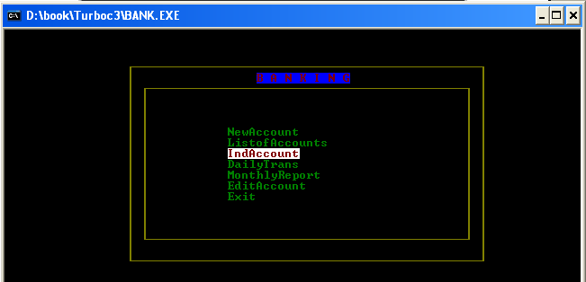

When we enter third option indAccount then following window will be displayed.
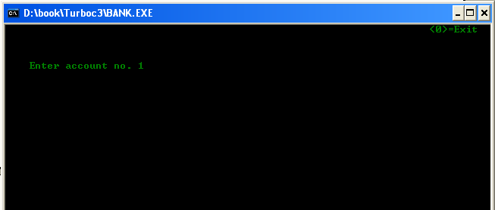

After enter the account number :- 1 the OUTPUT is

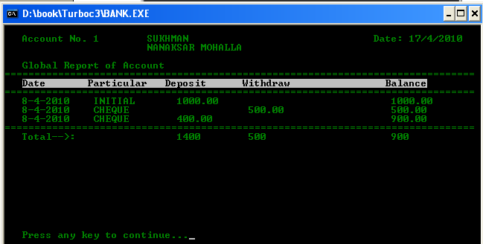

When enter our choice : DAILY TRANSACTION

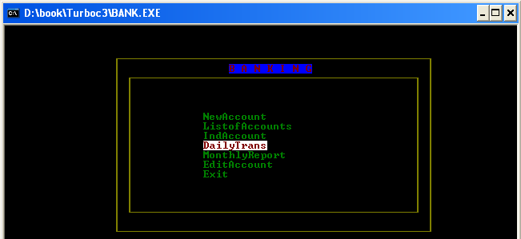

Output obtained by choosing the FOURTH option then enter the account number.

After enter the account number :-1 , enter the transaction of deposit or withdraw in account then enter the amount in cash or cheque last option enter the amount in rupees and then save the transaction yes or no.

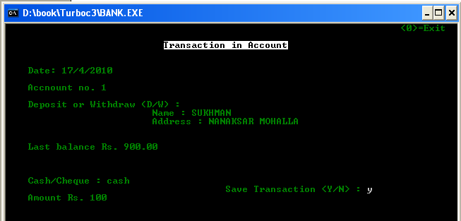

When enter our choice : MONTHLY REPORT

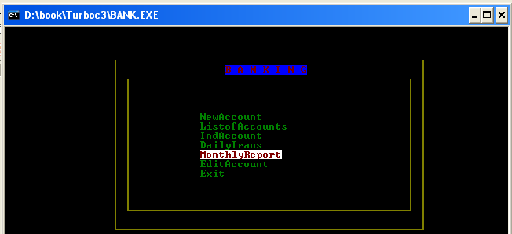

Output obtained by choosing the FIVTH option is show the all monthly report of account.

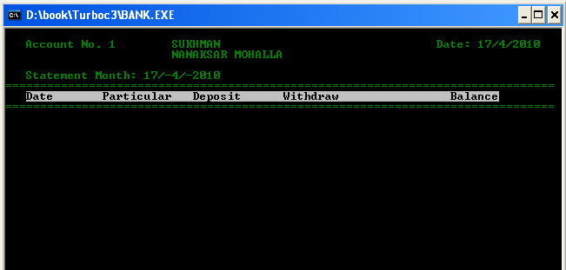

When enter our choice : EDIT ACCOUNT

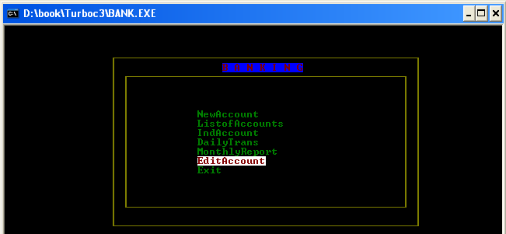

Output obtained by choosing the SIXTH option is modify the account and close the account and quit is used for exit from the edit menu.

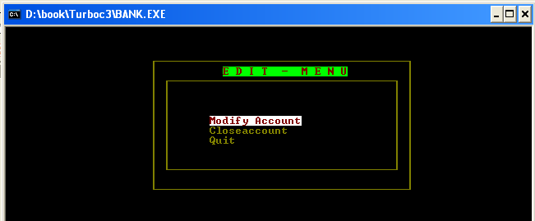

When enter the Modify account ,first enter the account number then enter the modify this account yes or no.

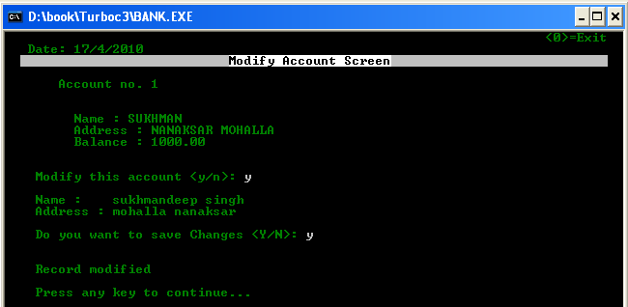

When enter the close account, first enter the account number and then delete the account yes or no.

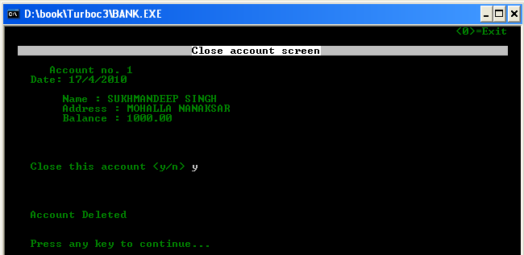

When press the quit ,then exit from the edit menu.

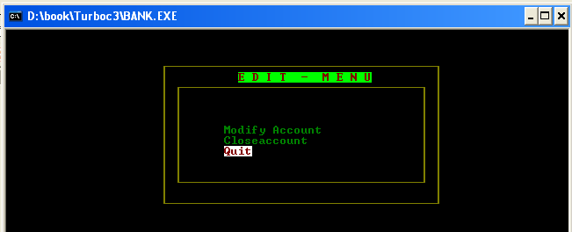

When enter our choice : EXIT
Then exit from the banking project

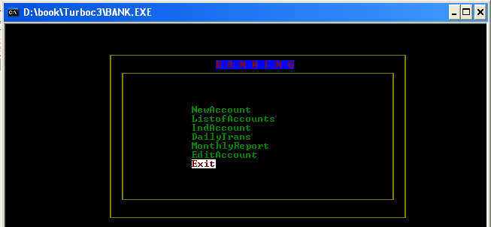

Conclusion

This project keeps the record of accounts. It is a very simple project for handle the record of accounts. This project is time saving as it saves the time of the workers as well as customers. It calculates balance quickly and correctly. It reduced the paper work. The main advantage of this project is that it converts all the manual work which is time consuming and error prone to fully automated system which helps in eliminating all the paper work, saves time, improves customer services.

SCOPE IN FUTURE

This project is use to keep the record of accounts in the bank. It is very easy to way for keeps the record of accounts. With the help of this project our time will save because about the all the accounts can directly view in the record. The storage enhancement provide benefit in the form of cost saving. In this project we can see easily exact time, day and month of deposit or withdraw the amount. Complicated calculations can be done more easily. Thus balance can be prepared more quickly and with more accuracy just by choosing the correct option which calculates the balance automatically.

BIBLIOGRAPHY

- Books

- Object Oriented Programming using C++ by :-

Vipan Arora

- Object Oriented Programming using C ++ by:-

Hemant kapila.

Websites:
- www.google.com
- www.wikipedia.com

